Technology inspired by ecology
Innovative drive system delivers ground-breaking efficiency
Kaeser Compressors is proud to announce yet another significant technological milestone for the company. For the first time, the ASD series of variable-speed rotary screw compressors will be equipped with synchronous reluctance motors – a major efficiency advantage thanks to considerably lower losses in the crucial partial-load range, compared to asynchronous motors.
From moving to the high efficiency IE3 motors long before the current regulations came into effect, to more recently taking the next step to enhance energy efficiency further by upgrading all compressors from 30 – 215 kW with the super-premium efficiency IE4 motors – Kaeser is committed to the ongoing optimisation of its compressed air production systems. As Peter Eckberg, Managing Director at Kaeser Compressors Australia said; ‘High end compressor quality is directly coupled with maximum energy efficiency, so it’s only logical that we provide our customers with the best drive solutions possible.’
Kaeser is now releasing its ASD series of variable-speed rotary screw compressors with a completely new drive technology. The major advantage of this complete solution, which was developed in close partnership with Siemens, is that it delivers efficiency gains of up to ten percent in the partial-load range. As Eckberg explains, this is yet another milestone in Kaeser’s ongoing history of technological success: ‘Although this drive principle has been understood for decades, only now has its implementation in production series motors attained the technical perfection required to benefit users throughout the world.’
Variable-speed drive with high system efficiency
‘From our perspective, implementation of such a systematic efficiency improvement – specifically in the partial-load range – is a logical step considering the climate protection efforts currently being codified by all governments around the world.’ emphasises Eckberg. Shifting to technological implementation, he continues, ‘With our variable-speed versions of the ASD series, we offer customers an opportunity to embark on a path of minimal energy consumption – and minimal operating costs.”
As an industry leader Kaeser understands the huge significance of the new Siemens synchronous reluctance motors, which were developed, in part, as a result of new regulatory frameworks. The new EN 50598 eco-design standard applies not only to the efficiency values of individual drives, as previous legislation did; but, it also represents a shift in regulatory emphasis to overall system efficiency. Consequently, the compliance of variable-speed drive solutions will now be assessed based on their overall system efficiency, not by the efficiency of each stand-alone component.
This is important because compressed air stations are often constructed on a modular basis. Continuously running compressor systems with IE3 and IE4 motors cover base load demand, whilst additional peak-load compressors respond flexibly to meet extra demand; the system as a whole is controlled and co-ordinated by a Sigma Air Manager 4.0 master controller to ensure maximum efficiency. With the Siemens synchronous reluctance drive systems, this will be performed with even greater efficiency, particularly in the all-important partial load range.
Combining the best of synchronous and asynchronous motor technology
This new and innovative range of general-purpose motors combines the advantages of both asynchronous and synchronous motors in a single drive system.
On the one hand, no aluminium, copper or expensive rare earth magnets are used in the rotors; instead they are made of electrical steel with a specialised profile and arranged in series – making the drive highly durable and maintenance friendly, the characteristic advantages of asynchronous motors. On the other hand, the control properties of the new motors are comparable to those of synchronous motors. Because of the special rotor design, reluctance motors deliver high speeds without additional rotor warming due to current flow. The key to this lies in optimised matching of the drive system elements, i.e. the motor and frequency converter, for which Kaeser selected the Sinamics G120 (also from Siemens). This frequency converter has been individually adapted to the motor using a specially developed control algorithm – and it is the perfectly harmonised interplay between these two components that makes the new synchronous reluctance drive system so powerful – and allows it to deliver maximum energy savings.
Eckberg continues: ‘Together with our development partner, Siemens, we have optimised this innovative drive to such an extent that speeds of 4,000 rpm are possible. Therefore, in addition to energy efficiency, users also benefit from even greater motor power – without any increase in the physical size of the motor. In fact, the housing and foot measurements of the synchronous reluctance motor are exactly the same as that for the asynchronous motor. In short, direct substitution is straightforward, requiring no major re-engineering effort, which provides users with the flexibility to decide which drive version they prefer for each application. It is this kind of systematic thinking that underscores our entire standardisation strategy’.
Same size – considerably better performance
With the variable-speed series and synchronous reluctance drive system, Kaeser Compressors has achieved yet another technological milestone. It is that much more remarkable considering that these compressors were previously equipped with a frequency converter and IE3 energy-saving asynchronous motors – and therefore already represented the pinnacle of environmentally friendly compressed air production.
Kaeser aims to equip even more performance classes with reluctance motors in the coming years, which will deliver noticeably improved performance from a machine of the same dimensions. Extending this to other performance classes promises to be a straightforward task thanks to the powerful partnership with Siemens, which delivers a fully tested, optimised and perfectly tuned system solution to Kaeser.
Some of the technical advantages of the new motor design include near zero heat losses from the rotors, which keeps bearing temperatures noticeably lower. This in turn has a positive effect on service life, ease of maintenance, as well as drive availability. ‘The optimal thermal capacity of the motors enables even longer service intervals than we had previously been able to offer,’ explains Eckberg. The positive effects also extend to control cabinet cooling, since less heat needs to be dissipated. Moreover, Kaeser’s use of variable-speed fans in compressed air production systems delivers additional energy savings.
An innovative drive system for a sustainable future
The new drive technology delivers efficiency gains of up to ten percent in the partial-load range, top IES2 classification as per the new EN 50598 efficiency standard, as well as significantly lower energy costs. This translates into average energy cost savings of around $675 per year, according to the compressor manufacturer (based on 6,000 operating hours at a rate of 10 cents per kilowatt-hour).
These benefits are in no small part due to the innovative functional design employed by Siemens when developing these new synchronous reluctance motors. Dispensing with expensive materials such as aluminium, copper and rare earth magnets for rotor construction boosts cost-effectiveness and also yields significant thermal advantages – primarily in the partial-load range. These motors, built on the platform of the energy-efficient 1LE1 asynchronous motor, are now available under the name Simotics GP/SD with aluminium and cast iron castings as standard.
Users therefore not only enjoy maximum flexibility for specific applications and varying environmental conditions, but also with regards to load response. Together with its high efficiency IE4 asynchronous motors, Siemens has now raised the bar of drive technology efficiency to a new level, exerting environmentally friendly competitive pressure across the market. Eckberg concludes: ‘Environmental issues are key when it comes to high quality compressor solutions, because it is these issues that will drive industry toward a truly sustainable future.’

File: A-Siemens-nz
Approved for publication, copy acknowledgement appreciated
Image:

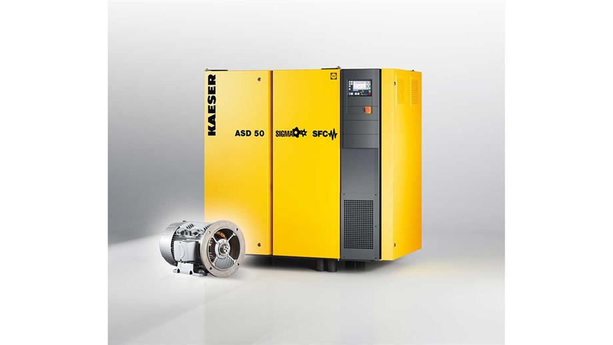
Caption: Kaeser’s variable-speed versions of ASD rotary screw compressors are available with a synchronous reluctance drive system from Siemens.

