May 2018

SMart evolution:
Kaeser launch latest generation SM series

Kaeser Compressors recently announced the launch of its latest generation SM series rotary screw compressors which are now even more efficient thanks to a number of smart product enhancements.

For maximum efficiency, the SM 13 and SM 16 compressor models are now equipped as standard with a super-premium efficiency IE4 motor that complies with and exceeds prevailing Australian GEMS regulations for 3 phase electric motors. IE4 motors are the technology of tomorrow, with current regulation introduced in January 2015 only requiring the use of IE3 Class motors. For the end user this translates into best possible compressor performance, reduced energy costs and significantly enhanced compressed air production efficiency - today.

For even greater intake volume and efficiency, the latest generation of SM series rotary screw compressors are also equipped with the new SIGMA 06 screw compressor block, featuring even further refined Sigma Profile rotors. Together with the IE4 motor, Kaeser has been able to reduce the energy requirement of these compressors by up to 13 percent.

All SM series compressors incorporate a Sigma Control 2. With this internal controller, compressor performance can be precisely adjusted to match respective compressed air consumption for optimum efficiency. The control unit features an easy to read display allowing all information to be viewed at a glance.
Where multiple compressors exist as part of a compressed air station, the Sigma Control 2 can easily be integrated with the master compressed air management controller from Kaeser - the Sigma Air Manager 4.0 (SAM 4.0). A key technology in the advanced world of Industrie 4.0, the SAM 4.0 seamlessly monitors and controls all components within a compressed air supply system for maximum cost savings, continuously fine-tuning system performance to ensure optimised energy efficiency. In addition, predictive maintenance is possible preventing unplanned downtime.

These latest generation models remain maintenance friendly. All maintenance work can be carried out from one side of the unit. The housing cover is easily removed to allow excellent component accessibility. In addition there is no need to remove the housing cover to inspect fluid levels or drive belt tension, as these can be checked via a convenient inspection window. Sound levels as low as 62 dB(A) furthermore ensure whisper-quiet performance making them the ideal choice for point of use applications.

The SM series of rotary screw compressors from Kaeser are available with drive powers of 5.5 to 9 kW, and produce flow rates from 0.59 to 1.62 m³/min, designed for pressures 7.5 to 15 bar. Visit www.kaeser.co.nz or phone 0800 447 820 for more information.
-END-
Editors Notes
From 2.2 to 500 kW, Kaeser Compressors manufactures a wide range of compressors and associated auxiliary equipment that meet the varying requirements of a diverse range of industries and applications.

One of the world’s largest manufacturers of rotary screw compressors, Kaeser Compressors is represented globally in over 100 countries through a dedicated network of branches, subsidiary companies and authorised partners.

Kaeser Compressors NZ Limited provides comprehensive air compressor and blower sales and service throughout New Zealand from its offices in Auckland, alongside a dedicated and nationwide network of authorised partners.

For editorial and advertising enquiries contact: Beth Wood, Marketing Manager
Press office: +61 3 9791 5999 Fax: +61 3 9791 5733
E-mail: beth.wood@kaeser.com

KAESER COMPRESSORS NZ Limited – 18B Tarndale Grove, Albany, Auckland 0632, New Zealand
Phone: +64 9 941 0499 – www.kaeser.co.nz – E-mail: info.newzealand@kaeser.com

File: A-SM-2018-nz
Approved for publication, copy acknowledgement appreciated
Image:
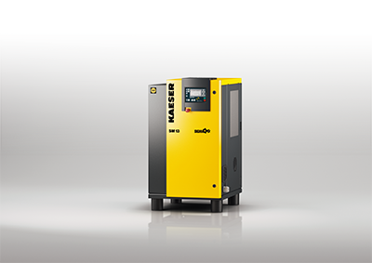

Caption: SMart evolution with the even more efficient latest generation models
011_Image 1_Kaeser SM13.jpg

((Kaeser photo – free for publication))

