July 2018

Rugged dependability:
Kaeser launches M210 series portable compressor

Kaeser Compressors has just announced the launch of its Mobilair 210 series portable compressor. Part of its larger range of diesel powered portable air compressors, the M210 is the ideal solution for continuous operation in tough environmental conditions - such as those applications found on mine sites - where free air deliveries of up to 21.2 m³/min are required.

Powered by a 146 kW diesel engine from Caterpillar with exhaust emission Tier 3, and featuring the flow optimised Sigma Profile screw compressor block, the new Mobilair 210 rotary screw compressors provide a free air delivery of 21.2 m³/min at 7 bar (g). In addition, 8.6 and 10 bar versions are available respectively delivering 19.7 and 18.0 m³/min.

At the heart of the M210 series portable compressor lies the Sigma Profile screw compressor block. Developed by Kaeser some years ago and continuously enhanced ever since, it achieves power savings of up to 15 percent compared with conventional screw compressor block rotor profiles. This contributes to the overall high efficiency of these compressors.
Part of the renowned Mobilair range of portable compressors from Kaeser that are manufactured at a state-of-the-art production facility in Germany, the recently launched M210 comes complete with a steerable axle chassis, foldable tow bar and parking brake. For the end user this ensures secure and space saving positioning of the compressor.

The M210 portable compressor features an impressive 420 litre PE fuel tank. Such a large capacity ensures the compressor has sufficient fuel to last an entire work shift. And, for extremely harsh environmental conditions, the M210 can optionally be supplied with a larger and stainless steel 450 litre fuel tank.

Thanks to the availability of a wide range of optional compressed air treatment components, the M210 can deliver compressed air at the required quality at all times. It is also available with a certified spark arrestor for refinery applications. And, even under extreme conditions, for example ambient temperatures of -10ºC up to +50ºC, the new M210 portable compressor from Kaeser dependably delivers the required compressed air at all times.

User- and service friendly, the M210 comes equipped as standard with the internal Sigma Control Smart controller. As such, the compressor is easy to operate, and the monitoring system can automatically shut the compressor down if necessary or report required maintenance.

For more information visit www.kaeser.co.nz or phone 0800 447 820.
-END-
From 2.2 to 500 kW, Kaeser Compressors manufactures a wide range of compressors and associated auxiliary equipment that meet the varying requirements of a diverse range of industries and applications.

One of the world’s largest manufacturers of rotary screw compressors, Kaeser Compressors is represented globally in over 100 countries through a dedicated network of branches, subsidiary companies and authorised partners.

Kaeser Compressors NZ Limited provides comprehensive air compressor and blower sales and service throughout New Zealand from its offices in Auckland, alongside a dedicated and nationwide network of authorised partners.

For editorial and advertising enquiries contact: Beth Wood, Marketing Manager
Press office: +61 3 9791 5999 Fax: +61 3 9791 5733
E-mail: beth.wood@kaeser.com

KAESER COMPRESSORS NZ Limited – 18B Tarndale Grove, Albany, Auckland 0632, New Zealand
Phone: +64 9 941 0499 – www.kaeser.co.nz – E-mail: info.newzealand@kaeser.com

File: C-M210-nz
Approved for publication, copy acknowledgement appreciated
Image:

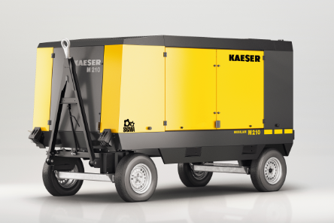
Images:
Caption: The M210 comes complete with a steerable axle chassis, foldable tow bar and parking brake
015_Image 1_KAESER M_210.jpg

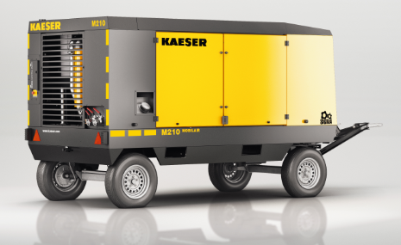
Images:
Caption: The M210 is the ideal solution for continuous operation in tough environmental conditions
015_Image 2_KAESER M_210.jpg

((Kaeser photo – free for publication))

