Rugged efficiency with the new Mobilair M235
Designed for continuous site operation under tough environmental conditions, the new Mobilair M235 diesel powered air compressor is the ideal solution for large portable compressor applications such as those found on mine sites.
Part of the renowned Mobilair range of portable compressors that are manufactured at a state-of-the-art production facility in Germany, the new M235 from Kaeser dependably delivers the required compressed air at all times – even under extreme conditions such as; at altitudes of 3000m above sea level or ambient temperatures up to 50ºC. In addition, the powerful combination of the highly efficient Kaeser Sigma Profile rotary screw compressor block and an energy-saving 194 kW Cummins engine provides impressive performance and fuel efficiency.
At the heart of every Mobilair portable compressor lies a high performance Kaeser rotary screw compressor block equipped with the flow-optimised and energy saving Sigma Profile rotors. Designed for optimum energy efficiency, the Kaeser Sigma Profile achieves power savings of up to 15 percent compared with conventional screw compressor block rotor profiles.
Ideal for large portable compressor applications such as those found on mine sites, the M235 from Kaeser has been designed to operate in tough conditions. The building site chassis with steerable axle and foldable tow bar, combined with the parking brake, ensures secure and space saving positioning of the compressor, as well as making it the ideal compressed air companion for no-road going areas. Also on board is a recessed lifting eye and fork-lift pockets for ease of transportation. Frost proof protection is assured – even at the coldest times of the year – thanks to the compressed air aftercooler. Compressed air is cooled to 7ºC above ambient temperature and the condensate is dependably removed via a flow-optimised axial centrifugal separator. The condensate is subsequently evaporated with the environmentally friendly use of hot exhaust gases from the engine.
The Mobilair M235 has a generously dimensioned fuel tank. When filled, this ensures that there will be sufficient fuel for an entire work shift without the need for refuelling. For ease of operation, the fuel level can be seen at a glance via the analogue fuel gauge and an automatic shut-down feature is activated when the fuel level is too low. A pre-warning from the Sigma Control Smart controller provides additional peace of mind.
All M235 portable compressors come with safety air filters as standard. Optimised design and separate air filters, including the safety element for the engine and compressor, considerably enhance reliability and service life. The filters can be changed on-site quickly and easily as required.
Like all other Kaeser compressors, the Mobilair M235 is user- and service- friendly. Equipped with a Sigma Control Smart controller that is protected by a durable metal cover, the compressor can be operated with just three buttons. In addition, the monitoring system can automatically shut the compressor down if necessary or report required maintenance. The enclosure components ensure long-term corrosion protection and value retention thanks to high quality zinc priming and tough powder coating. Furthermore, large enclosure doors provide easy access to a well-designed interior. Service and maintenance can be carried out quickly and effectively, thereby ensuring maximum efficiency and compressed air availability.
The M235 is available with a certified spark arrestor for refinery applications. In addition, the engine shut-off valve automatically shuts down the unit upon intake of combustible gases to ensure maximum safety.
The Mobilair M235 is also an ideal back-up air supply solution for industry and a skid mounted version is available where the M235 is required for a stationary application. Thanks to the availability of a wide range of optional compressed air treatment components, the M235 can deliver compressed air at the required quality at all times. Models are available in various pressure versions ranging from 8.6 to 14 bar, with free air deliveries from 18.1 to 23.3 m³/min.

File: c-m235-nz
Approved for publication, copy acknowledgement appreciated
Image:

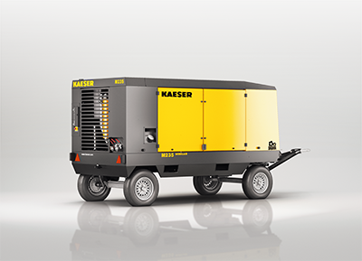
Rugged and efficient - the new Mobilair M235 from Kaeser

