July 2018

Industrie 4.0-ready medical compressed air:
Kaeser at IFHE 2018 Congress

Kaeser Compressors to present its Industrie 4.0-ready medical compressed air system solutions at the IFHE 2018 Congress.

Kaeser will be exhibiting at the International Federation of Hospital Engineering 2018 Congress. Being held at the Brisbane Convention and Exhibition Centre in Australia from 6-11 October 2018, visitors to the Kaeser stand will be able to learn more about the Industrie 4.0-ready medical compressed air system solutions that Kaeser Compressors has to offer.

This includes Kaeser’s latest range of CSG-2 series dry-running rotary screw compressors. Available with drive powers ranging from 37 to 90 kW, these two-stage machines provide free air deliveries from 5.4 to 13.1 m³/min for pressures between 4 and 10 bar (g). Together with the existing DSG-2 and FSG-2 series, Kaeser‘s dry-runner range covers free air deliveries ranges from 5.4 to 50.0 m³/min, and 3.2 to 50.8 m³/min for variable speed machines.

Delivering ultra-efficient compressed air production at all times, the CSG-2 systems are the ideal choice where absolutely clean and dry compressed air is required, such as in the medical sector.

At the heart of these versatile units lies a quality, two-stage compressor block. The rotors are equipped with ‘ultra coat’ which is resistant to temperatures up to 300ºC. This cost reducing coating is highly abrasion-proof. After years of operation, its sealing and protection performance therefore remains virtually unchanged. For the end user this ensures that these compressors consume no more energy after years of use than when first commissioned in order to deliver their rated free air delivery. This subsequently contributes to keeping total system costs to a minimum.
Energy efficiency is further enhanced through the inclusion of an IE4 super premium efficiency drive motor, which complies with and exceeds prevailing New Zealand EECA regulations for 3 phase electric motors.

The inclusion of a Sigma Control 2 internal controller additionally contributes to the dependability and efficiency of a Kaeser dry-running screw compressor. A powerful combination of multiple control modes, a timer and base load sequencing provide energy savings. Moreover, a precision electronic pressure sensor keeps switching differential to a minimum thereby saving even more energy.
The Sigma Control 2 also offers further advantages. This advanced system provides greater flexibility through its numerous interfaces and innovative plug-in communication modules. Connection to energy-saving master control systems such as the Sigma Air Manager 4.0 (SAM 4.0) couldn’t be easier.

The advanced SAM 4.0 master compressed air controller from Kaeser is a key technology that also opens up the compressed air system to the advanced world of Industrie 4.0. As the central mastermind, the SAM 4.0 controls the entire compressed air supply system and - via the Internet of Things (IoT) - it is responsible for data streaming to a centralised application.

In the ultra-flexible Industrie 4.0 production environment, intelligently networked Kaeser compressed air systems therefore reliably provide the necessary compressed air volumes and quality required to meet the needs of any application. Moreover, potential issues in the compressed air network are detected very early on, so that specific service calls can be arranged before a fault even occurs. This is made possible with real-time information. Production efficiency and flexibility can therefore be increased as a whole.

To learn more about Kaeser’s comprehensive range of Industrie 4.0-ready, medical compressed air system solutions, visit the Kaeser stand at the IFHE 2018 Congress. 6-11 October 2018, Brisbane Convention and Exhibition Centre in Australia.

For more information visit www.kaeser.co.nz or phone 0800 447 820.
-END-
From 2.2 to 500 kW, Kaeser Compressors manufactures a wide range of compressors and associated auxiliary equipment that meet the varying requirements of a diverse range of industries and applications.

One of the world’s largest manufacturers of rotary screw compressors, Kaeser Compressors is represented globally in over 100 countries through a dedicated network of branches, subsidiary companies and authorised partners.

Kaeser Compressors NZ Limited provides comprehensive air compressor and blower sales and service throughout New Zealand from its offices in Auckland, alongside a dedicated and nationwide network of authorised partners.

For editorial and advertising enquiries contact: Beth Wood, Marketing Manager
Press office: +61 3 9791 5999 Fax: +61 3 9791 5733
E-mail: beth.wood@kaeser.com

KAESER COMPRESSORS NZ Limited – 18B Tarndale Grove, Albany, Auckland 0632, New Zealand
Phone: +64 9 941 0499 – www.kaeser.co.nz – E-mail: info.newzealand@kaeser.com

File: O-IFHE-2018-nz
Approved for publication, copy acknowledgement appreciated
Image:

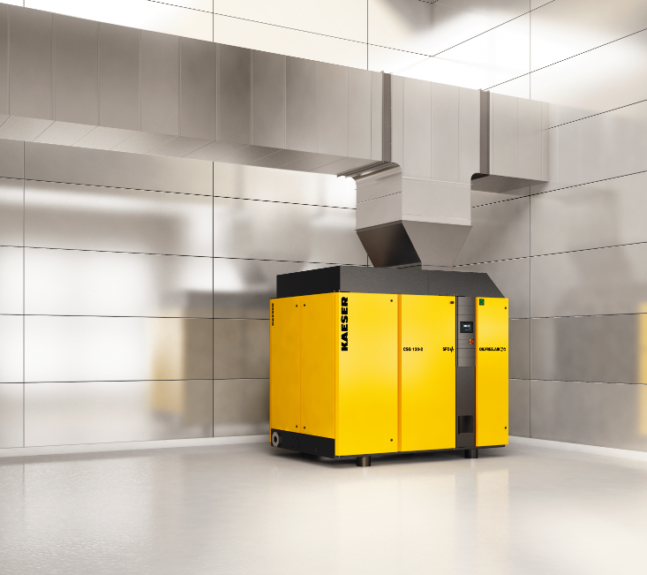
Caption: Kaeser’s medical compressed air system solutions are Industrie 4.0-ready
014_Image 1_KAESER_CSG_120_2.png

((Kaeser photo – free for publication))

