Kaeser launch latest generation activated carbon adsorbers:
Dependable protection for sensitive production processes
Kaeser Compressors has just announced the launch of its latest generation ACT series activated carbon adsorbers. Delivering a continuous supply of premium quality compressed air that is technically oil-free, these energy saving, exceptionally reliably and service friendly activated carbon adsorbers, ensure dependable protection of sensitive production processes.
The latest generation ACT series activated carbon adsorbers from Kaeser are able to deliver a continuous supply of premium quality compressed air that is technically oil-free as well as odour- and taste- neutral. Installed downstream of compressed air drying and pre-filtration components, they attain Class 1 residual oil content as per ISO 8573-1, to ensure dependable protection of sensitive production processes. This makes the ACT series the ideal choice for applications in the; optical, surface technology, electronics, foodstuffs and pharmaceutical sectors.
In order to meet the strictest ISO 8573-1 Class 1 compressed air purity class requirements, compressed air should have a residual oil content of no higher than 0.01 mg/m³. Class 1 compressed air is therefore significantly cleaner than typical ambient air. For this reason compressed air treatment is essential irrespective of the compression method that is used to produce it.
To achieve this level of purity, more is needed than to simply remove the residual oil content via filters. The vapour component also needs to be retained by means of adsorption on activated carbon. The high performance ACT series activated carbon adsorbers from Kaeser can achieve residual oil content significantly lower than the threshold value for Class 1 compressed air purity.
Generously dimensioned flow diameters, together with stainless steel flow diffusers, ensure even flow distribution with an exceptionally low pressure loss no higher than 0.1 bar. As a result, the compressor discharge pressure of upstream compressors, as well as the energy costs for compressed air production, can be kept as low as possible. The ACT series activated carbon adsorbers from Kaeser are exceptionally reliable. They utilise a high quality and generously sized activated carbon filling. Optimised for gas purification, this special type of activated carbon is fine pored and possesses an exceptional retention capacity. Furthermore, specially designed stainless steel flow diffusers ensure even flow distribution throughout the activated carbon bed. Consequently, the exceptional compressed air purity is reliably assured for up to 12,000 full load hours, or a maximum of five years.
Low life cycle costs are also assured with the latest ACT series models. Thanks to significantly longer service intervals, the life-cycle costs of the ACT models can equal those of high quality activated carbon filters in their third year. In the following years they are by far the more cost-effective alternative. This advantage is further bolstered by better compressed air availability resulting from the lower number of necessary service visits.
Kaeser ACT series activated carbon adsorbers have very long replacement intervals thanks to their generous dimensions and optimal flow dynamics through the highly effective activated carbon. They are also mounted in a protective and exceptionally durable steel base frame.
The latest generation of activated carbon adsorbers from Kaeser not only ensure dependable protection of sensitive production processes but, they are also exceptionally reliable, service friendly and energy saving. Flow rate from 1.17 to 154.53 m³/min, pressure 4 to 48 bar.

File: d-ACT-aus
Approved for publication, copy acknowledgement appreciated
Image:

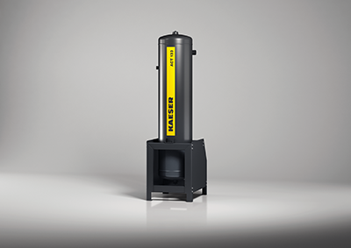
Dependable protection for sensitive production processes is assured with the latest generation ACT series from Kaeser

