Ready, set – innovate!
Following almost two years of construction, Kaeser Compressors’ new Research & Innovation Centre is now ready to open its doors.
Kaeser’s new and expansive Research & Innovation Centre at its headquarters in Coburg, Germany, is now ready for occupancy. The expansive building has been constructed with innovation in mind, bringing together departments who work closely together but were previously based in separate buildings which were some distance apart on the Kaeser grounds.
The new light-filled work areas have been specifically designed to promote ease of communication amongst the research and development teams – thereby promoting innovation. Coupled with a general need for more space, the foundation was therefore laid in September 2015 for this new ‘Research & Innovation Centre’. As Thomas Kaeser, Chairman of the Board, explains: ‘Because the employees are now much closer together, they’ll be able to communicate more easily. In turn, this promotes a steady flow of new ideas and innovations that will help to solve specific development issues.’
The building’s open-concept design incorporates large glass panels to take full advantage of natural light, whilst the office dimensions have been specially designed with employees’ needs in mind – and can be flexibly adjusted later as well. The Strategic Purchasing, Strategic Product Marketing and Technical Product Development departments are now housed in the new Centre.
A double-spiral staircase connecting all six storeys stands out as a special architectural highlight. The staircase design is based on the Sigma Profile of the rotary screw rotors that play such an important role in Kaeser’s success as a company. Rotary screw rotors are essentially two interconnected spirals; they are at the very heart of a rotary screw compressor and are the components that actually compress the ambient air to produce compressed air.
Kaeser first developed a highly energy-efficient version of these rotors in the 1970s and continues to refine this technology today. As Thomas Kaeser explains, ‘Continued innovation is essential. After all, the future belongs to those who push the boundaries of development ever further to chart new territory and who are open to new ideas and concepts. Kaeser’s future will be just as successful as its present and past.’
The building’s climate control system is also highly innovative. For example, heating elements have completely disappeared. Instead, ventilation takes place through the ceiling, which radiates cold or heat – depending on the conditions outdoors.
Suppliers primarily from the region worked on the construction of the building.

File: p-FIZ-nz
Approved for publication, copy acknowledgement appreciated
Images:
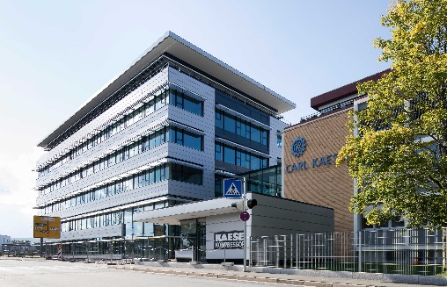
Now ready for occupancy, Kaeser Compressors’ new Research and Innovation Centre promises to deliver many new innovations.
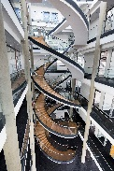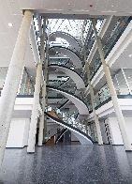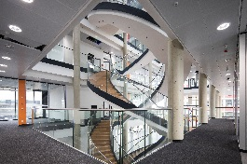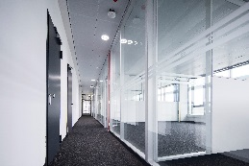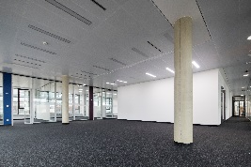
Expansive, light-filled rooms and an open-concept design are intended to promote communication within the building. The double-spiral staircase is a special architectural highlight that connects the building’s six storeys.

